**A step-by-step tutorial to create a simple web service using ASP.NET Core without a database**.

This example will demonstrate how to build a RESTful API that returns JSON data, focusing on the interaction between the Model and Controller.

**Step 1: Create a new ASP.NET Core Web API Project**

Open a terminal or command prompt and run the following commands:

Command below will create a direcwetory (mkdir stands for make directory, and a folder will be created in your current or default directory), if you want to move to a desired directory then use cd command for example: cd desktop and then write mkdir SimpleWebApi to create a folder SimpleWebApi on desktop.

* mkdir SimpleWebApi

Navigate to the project directory

* cd SimpleWebApi

Create a new ASP.NET Core Web API project

* dotnet new webapi

**Step 2: Open the Project in Visual Studio Code**

If you're using Visual Studio Code, open the project folder by running (make sure you have launched VS code in apps anywhere first):

* code .

**Step 3: Explore the Project Structure**

Open the **Controllers** and **Models** folders (Create **Models** and **Controllers** folder inside the folder SimpleWebApi if they are not auto generated)

**Step 4: Add a Model**

Create a new file named Item.cs in the Models folder with tSI he following content:

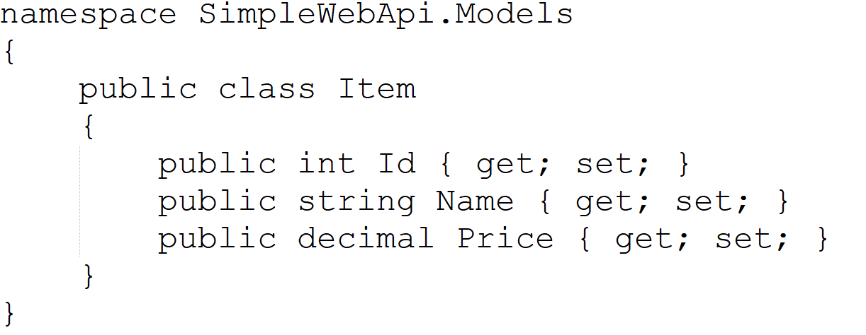

**Step 5: Create a Controller**

Create a file named **ItemsController.cs** in Controllers folder. Write the following code in that file:

This code defines a simple ItemsController with two actions:

**Get:** Returns a list of items.

**Get(id):** Returns a specific item based on the provided id.

**Step 6: Run the Application**

Run the following command in the terminal to start the application:

* dotnet run

The application will be accessible at https://localhost:5000. Refer to SimpleWebApi.http file for your port number, you might have a different port number. You can test the API by navigating to https://localhost:<yourPort>/api/items in your browser if you can see some JSON data returned when your url is http://localhost:<yourPort>/weatherforecast/ but can’t see anything when url is [http://localhost:<yourPort>/api/Items](http://localhost:%3cyourPort%3e/api/Items) then you are missing Controllers dependency and mapping in your program.cs so go to program.cs and at the top after builder variable declaration add

* builder.Services.AddControllers();

and after app.UseHttpsRedirection(); add

* app.MapControllers();

You can also use tools like curl, Postman, or a web browser.

**Step 7: Test the API Endpoints**

To get all items: https://localhost:5001/api/items

To get a specific item (e.g., item with Id 1): https://localhost:5001/api/items/1

You should see JSON responses containing the item data.

That's it! You've successfully created a simple ASP.NET Core Web API without a database, focusing on the Model (Item) and the Controller (ItemsController). You can expand upon this example by adding more models, controllers, and actions based on your application's needs.